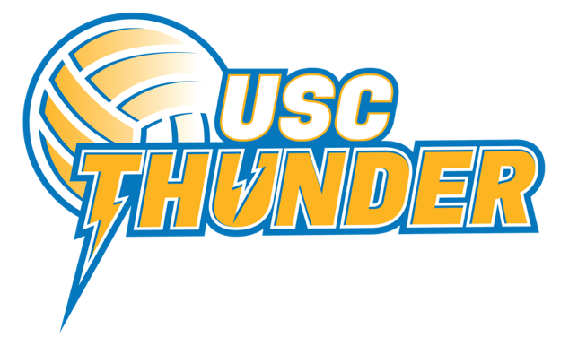

2022 NISSAN STATE TITLES TEAM MANAGER APPLICATION

Name:
Address:
Phone (mobile):
Email:
Team: Under 16’s | Under 18’s

- Please detail your previous experience as a Team Manager:

- Please outline what you believe are the priorities of your role:

- Please give an example of how you have incorporated your values into your managing role:

- What learnings have you taken on board in the last 2 years that have helped you to be more effective in your role?

Please return this form with your 1-page resume and covering letter to ops@thundernetball.org.au

Applications must be received by Friday 17th June 5pm

