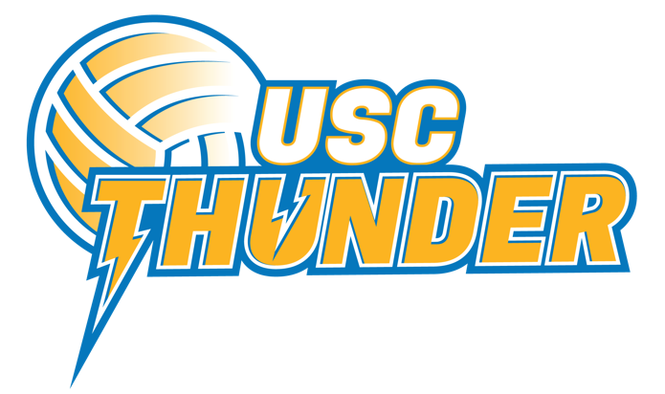
2022 NISSAN STATE TITLES
COACHING APPLICATION FORM

Name:
Association:
Current Team:
Phone (mobile):
Email:
Team: | Under 16’s Under 18’s
Position: | Head Coach Assistant Coach
Coaching Accreditation Level:
Year Attained Accreditation:

- Please outline your coaching philosophy:

- Please detail your greatest successes as a coach and how you contributed to this:

- Please outline your greatest challenge as a coach and how you are working to overcome this?

- Please give an example of how you have incorporated your values into your coaching:

- Please list any formal and informal coaching professional development opportunities you have undertaken in the last 2 years (e.g. attendance at coaching workshops or forums within netball or other sports, part of coaching groups, books read, regular podcasts listened to, accreditation courses (netball or other sports)):

Please return this form with your CV (1 page only) and covering letter to ops@thundernetball.org.au

Applications must be received by Friday 17th June 5pm

